

PROJECT 2 REPORT

ADVANCE E-COMMERCE WEBSITE

DONE BY: TANIYA MAHESHWARI

ABSTRACT

Around the world, the digital world is linked to cutting-edge technologies and current technology. The daily operations of our businesses and organizations are now more efficient thanks to the internet and technological devices like computers. Information on the World Wide Web (WWW) can be viewed online. The design and development of a website involves several processes. Usually, the designer must first choose the website's ultimate goal in consultation with the client or other stakeholders. Every website needs an effective sitemap as its foundation. It makes the relationships between pages and content pieces and the information architecture of the website clear. Once the architecture of your website is finished, you may start producing content. Engaging and motivating users as well as search engine optimization are the two key roles that content plays. Users are engaged by content, and this encourages them to engage in actions that further a website's objectives. Lastly, create the aesthetic theme for the website. This step of the design process is frequently affected by branding elements, colors, and logos supplied by the client. A talented site designer may really shine on this stage. Images are now more important than ever in the design of websites. High-quality images not only appear and feel professional, but they also convey a message, appear to be mobile-friendly, and foster confidence. Clicks, engagement, and money all increase with visual content. However, users expect images on websites. Once the website has all of its visual appeal and content, testing is ready. To verify that all links function properly and that the site runs quickly on all browsers and devices, thoroughly test each page.

OBJECTIVE

To create an advanced E-commerce website using HTML, CSS, and JavaScript (Bootstrap).

The front-end part is to be created with responsiveness towards change in ratio from screen to screen of the device used along with the storing of data entered by the user in the elements of the website. It should contain many hyperlinks to several sub-pages which complete the dynamic website.

INTRODUCTION

For this project, we link different web pages to the main index page created in the first project (basic website creation).

We learned how to add maps to the website, embed a video from YouTube along with sourcing video from personal dataspace and use controls over the video, and how to store information from the form provided by the user in the google spreadsheet document.

METHODOLOGY

In the basic website HTML code, we link Bootstrap CSS to HTML Using the Bootstrap Content Delivery Network (CDN). We also link Bootstrap CDN for icons used to display in the ‘Follow us’ part of the footer. Each element of the navigation bar is now a hyperlink to separate websites related to the company. We have separate HTML files for each website while all of them have a common CSS file linked to them. The register page contains a form, while the blog and service page contain information in card format. The contact page contains an embedded link of google map directions of the company’s headquarters. At the bottom, we use a script tag to link JavaScript plugins and spreadsheets. Putting JavaScript at the bottom means that the other page content (text especially) loads before the JavaScript so users are not waiting for the JS to load if they have slow connections. This does not affect the document. ready, as that is called when the browser has finished preparing the DOM for a page.

CODE:

HTML PART:

**File: indexx.html**

<!DOCTYPE html>

<html lang="en">

<head>

    <title>E-commerce</title>

    <meta charset="UTF-8">

    <meta http-equiv="X-UA-Compatible" content="IE=edge">

    <meta name="viewport" content=""width=device-width, initial-scale="1.0">

<!-- Latest compiled and minified CSS -->

<link rel="stylesheet" href="https://cdn.jsdelivr.net/npm/bootstrap@3.4.1/dist/css/bootstrap.min.css" integrity="sha384-HSMxcRTRxnN+Bdg0JdbxYKrThecOKuH5zCYotlSAcp1+c8xmyTe9GYg1l9a69psu" crossorigin="anonymous">

<!-- Optional theme -->

<link rel="stylesheet" href="https://cdn.jsdelivr.net/npm/bootstrap@3.4.1/dist/css/bootstrap-theme.min.css" integrity="sha384-6pzBo3FDv/PJ8r2KRkGHifhEocL+1X2rVCTTkUfGk7/0pbek5mMa1upzvWbrUbOZ" crossorigin="anonymous">

    <link rel="stylesheet" type="text/css" href="style.css">

    <link rel="stylesheet" type="text/css" href="https://stackpath.bootstrapcdn.com/font-awesome/4.7.0/css/font-awesome.min.css">

</head>

<body>

    <nav class=" nav nav_top">

        <div class="logo">

            <a href="indexx.html"><img src="C:\Users\HP\Desktop\C codes\.vscode\HTML\PROJECT1\1Stoplogo.png" width="150"></a>

        </div>

        <div class="nav_side">

            <a href="about.html">About Us</a>

            <a href="service.html"> Services</a>

            <a href="blog.html">Blogs</a>

            <a href="contact.html">Contact</a>

            <a href="register.html">Login/Register</a>

        </div>

    </nav>

    <div class="main">

        <div class="main_content">

            <h2> Education is a form of art and creativity<br>

                <span>"Learn, Grow, Prosper"</span><br>

                <span>1stop is a strong platform with immense potential for students from anywhere and anytime to access cutting-edge Mentorship and Certification Program widespread with a larger number of domains and niches to explore learning.  </span>

            </h2>

            <div class="btn">

                <a href="service.html"> START NOW</a>

            </div>

        </div>

    </div>

    <div class="product">

        <h2> OUR COURSES</h2>

        <div class="product_container">

            <div class="item">

                <div class="item_img">

                    <img src="C:\Users\HP\Desktop\C codes\.vscode\HTML\PROJECT1\ecourse.jpg">

                </div>

                <div class="item_content">

                    <h3>Engineering</h3>

                    <p>Hello.This is a sample description of an engineering course.</p>

                    <a href="register.html">BUY NOW</a>

                </div>

            </div>

            <div class="item">

                <div class="item_img">

                    <img src="C:\Users\HP\Desktop\C codes\.vscode\HTML\PROJECT1\bcourse.jpg">

                </div>

                <div class="item_content">

                    <h3>Business</h3>

                    <p>Hello.This is a sample description of a unique business course.</p>

                    <a href="register.html">BUY NOW</a>

                </div>

            </div>

            <div class="item">

                <div class="item_img">

                    <img src="C:\Users\HP\Desktop\C codes\.vscode\HTML\PROJECT1\scourse.jpg">

                </div>

                <div class="item_content">

                    <h3>Social Sciences</h3>

                    <p>Hello.This is a sample description of a social science course.</p>

                    <a href="register.html">BUY NOW</a>

                </div>

            </div>

        </div>

        <div class="product_btn">

            <a href="service.html">Explore Our Courses</a>

        </div>

    </div>

    <hr>

    <div class="keypoint">

        <h2>OUR KEY HIGHLIGHTS</h2>

        <div class="key_container">

            <div class="key_content">

                <li>sample line 1</li>

                <li>sample line 2</li>

                <li>sample line 3</li>

                <li>sample line 4</li>

                <li>sample line 5</li>

                <li>sample line 6</li>

            </div>

            <div class="key_img">

                <img src="C:\Users\HP\Desktop\C codes\.vscode\HTML\PROJECT1\keyimg.jpg">

            </div>

        </div>

    </div>

    <div class="testi">

        <h2> Our Aim</h2>

    <div class="testi_container">

<div id="carousel-example-generic" class="carousel slide" data-ride="carousel">

    <!-- Indicators -->

    <ol class="carousel-indicators">

     <li data-target="#carousel-example-generic" data-slide-to="0" class="active"></li>

    <li data-target="#carousel-example-generic" data-slide-to="1"></li>

    <li data-target="#carousel-example-generic" data-slide-to="2"></li>

    </ol>

    <!-- Wrapper for slides -->

    <div class="carousel-inner" role="listbox">

        <div class="item active">

            <div class="item_img">

                <img src="C:\Users\HP\Desktop\C codes\.vscode\HTML\PROJECT1\slider1.jfif" alt="...">

            </div>

            <div class="item_content">

                <h3>INCREASED JOB OPPORTUNITIES</h3>

                <p> sample line 1 </p>

            </div>

        </div>

        <div class="item">

            <div class="item_img">

                <img src="C:\Users\HP\Desktop\C codes\.vscode\HTML\PROJECT1\slider2.png" alt="...">

            </div>

            <div class="item_content">

                <h3>MENTORSHIP IN RESUME BUILDING</h3>

                <p> sample line 2 </p>

            </div>

        </div>

        <div class="item">

            <div class="item_img">

                <img src="C:\Users\HP\Desktop\C codes\.vscode\HTML\PROJECT1\slider3.jfif" alt="...">

            </div>

            <div class="item_content">

                <h3>HELPING FIND GOOD INTERNSHIPS</h3>

                <p> sample line 3 </p>

            </div>

        </div>

    </div>

    <!-- Controls -->

    <a class="left carousel-control" href="#carousel-example-generic" role="button" data-slide="prev">

        <span class="glyphicon glyphicon-chevron-left" aria-hidden="true"></span>

        <span class="sr-only">Previous</span>

    </a>

    <a class="right carousel-control" href="#carousel-example-generic" role="button" data-slide="next">

        <span class="glyphicon glyphicon-chevron-right" aria-hidden="true"></span>

        <span class="sr-only">Next</span>

    </a>

</div>

</div>

</div>

<hr>

<div class="team">

    <h2> OUR TEAM</h2>

    <div class="team_container">

        <div class="team_video">

            <iframe width="560" height="315" src="https://www.youtube.com/embed/65xcAkmQEDk" title="YouTube video player" frameborder="0" allow="accelerometer; autoplay; clipboard-write; encrypted-media; gyroscope; picture-in-picture; web-share" allowfullscreen></iframe>

        </div>

        <div class="team_content">

            <p> Lorem ipsum dolor sit amet. Quo molestiae voluptatum 33 laudantium modi eum repudiandae sunt. Est quasi quaerat hic internos quod At reprehenderit iste ab laborum maiores aut maxime necessitatibus ex nesciunt harum hic beatae obcaecati. Sed voluptatem repellat vel soluta exercitationem est harum numquam. </p>

            <p>Sed maiores error est impedit quod ad delectus quibusdam rem facilis rerum eum blanditiis laudantium. Quo perspiciatis commodi sed iure consectetur ea aperiam debitis aut deserunt molestiae. Ut porro autem et nisi nostrum ut voluptates sequi est minima laboriosam. Ut voluptas quia qui dignissimos iste quo atque reiciendis vel dolorem nisi.</p>

        </div>

    </div>

</div>

<div class="feed">

    <h2> Write a review</h2>

    <div class="feed_form">

        <form name="submit_googlesheet" method="post">

            <input type="text" name="" placeholder="Name"><br>

            <input type="email" name="" placeholder="Email ID"><br>

            <input type="number" name="" placeholder="Contact Number"><br>

            <textarea rows="5" cols="7" name="" placeholder="Write your review"></textarea><br>

            <button type="submit">Submit</button>

        </form>

    </div>

</div>

<footer>

    <div class="logo">

        <a href="indexx.html"><img src="C:\Users\HP\Desktop\C codes\.vscode\HTML\PROJECT1\1Stoplogo.png" width="150"></a>

    </div>

    <div class="pages">

        <h3>Pages</h3>

        <a href="about.html">About Us</a>|

        <a href="service.html">Services</a>|

        <a href="blog.html">Blogs</a>|

        <a href="register.html">Sign Up/Sign in</a>

    </div>

    <div class="doc">

        <h3>Documents</h3>

        <a href="https://www.1stop.ai/images/1stopai%20PRIVACY%20POLICY.pdf" target="_blank">Privacy Policy</a>|

        <a href="https://www.1stop.ai/images/Terms%20of%20Use%20%20Final-%201Stop.Ai.pdf" target="_blank">Terms Of Use</a>|

        <a href="https://www.1stop.ai/images/Refund%20and%20Course%20Change%20Policy%201Stop.Ai.pdf" target="_blank">Refund Policy</a>

    </div>

    <div class="social">

        <h3>Follow Us</h3>

        <a href="https://www.facebook.com/people/1Stopai/100063830183617/" target="_blank"><i class="fa fa-facebook" aria-hidden="true"></i></a>

        <a href="https://www.instagram.com/1stop.ai/?hl=en" target="_blank"><i class="fa fa-instagram" aria-hidden="true"></i></a>

        <a href="https://www.linkedin.com/company/1stop-ai/?viewAsMember=true" target="_blank"><i class="fa fa-linkedin-square" aria-hidden="true"></i></a>

    </div>

    <div class="contact">

        <h3>Contact Us</h3>

        <a href="https://api.WhatsApp.com/send?phone=+919876543210" target="_blank"><a href=""><i class="fa fa-whatsapp" aria-hidden="true"></i></a></a>

        <a href="tel: +919876543210"><i class="fa fa-phone" aria-hidden="true"></i></a>

        <a href="mailto: support@1stop.ai"><i class="fa fa-envelope" aria-hidden="true"></i></a>

    </div>

    <hr>

    <p>Copyright &copy; 2021 1stop. All rights reserved</p>

</footer>

 <!-- jQuery (necessary for Bootstrap's JavaScript plugins) -->

 <script src="https://code.jquery.com/jquery-1.12.4.min.js" integrity="sha384-nvAa0+6Qg9clwYCGGPpDQLVpLNn0fRaROjHqs13t4Ggj3Ez50XnGQqc/r8MhnRDZ" crossorigin="anonymous"></script>

 <!-- Include all compiled plugins (below), or include individual files as needed -->

<!-- Latest compiled and minified JavaScript -->

<script src="https://cdn.jsdelivr.net/npm/bootstrap@3.4.1/dist/js/bootstrap.min.js" integrity="sha384-aJ21OjlMXNL5UyIl/XNwTMqvzeRMZH2w8c5cRVpzpU8Y5bApTppSuUkhZXN0VxHd" crossorigin="anonymous"></script>

<script type="text/javascript">

    const scriptURL = 'https://script.google.com/macros/s/AKfycbzVQri3Ta8S4sVbmDbsHW_ZyyvFThbLJu4ayuk4SEVRUaPrVlCN0BvVDQFomXP2Yih0/exec'

        const form = document.forms['submit_googlesheet']

        form.addEventListener( 'submit', e => {

        e.preventDefault()

        fetch(scriptURL, { method: 'POST', body: new FormData(form)})

        .then(response => alert("Thank You, will get back to you soon.."))

        .catch(error => console.error('Error!', error.message))

        })

</script>

</body>

</html>

**File: about.html**

<!DOCTYPE html>

<html lang="en">

<head>

    <title>E-commerce | About Us</title>

    <link rel="stylesheet" type="text/css" href="style.css">

    <link rel="stylesheet" type="text/css" href="https://stackpath.bootstrapcdn.com/font-awesome/4.7.0/css/font-awesome.min.css">

</head>

<body>

    <nav class=" nav nav_top">

        <div class="logo">

            <a href="indexx.html"><img src="C:\Users\HP\Desktop\C codes\.vscode\HTML\PROJECT2\1Stoplogo.png" alt="logo" width="150"></a>

        </div>

        <div class="nav_side">

            <a href="about.html">About Us</a>

            <a href="service.html"> Services</a>

            <a href="blog.html">Blogs</a>

            <a href="contact.html">Contact</a>

            <a href="">Login/Register</a>

        </div>

    </nav>

    <div class="about_us">

        <h2>About Us</h2>

        <div class="about_content">

            <p>1stop is a strong platform with immense potential for students from anywhere and anytime to access cutting-edge Mentorship and Certification Program widespread with a larger number of domains and niches to explore learning. E-learning has been the fastest growing way for an aspirant to start their journey into pursuing their Dream Career.</p>

        </div>

        <hr>

        <h2> Our Vision</h2>

        <p>Our Vision lies to bring in a technology-oriented career-driven Industrial Experience into the aspirant's career with Great Value </p>

    </div>

<div class="feed">

    <h2> Write a review</h2>

    <div class="feed_form">

        <form>

            <input type="text" name="" placeholder="Name"><br>

            <input type="email" name="" placeholder="Email ID"><br>

            <input type="number" name="" placeholder="Contact Number"><br>

            <textarea rows="5" cols="7" name="" placeholder="Write your review"></textarea><br>

            <button type="submit">Submit</button>

        </form>

    </div>

</div>

<footer>

    <div class="logo">

        <a href="indexx.html"><img src="C:\Users\HP\Desktop\C codes\.vscode\HTML\PROJECT2\1Stoplogo.png" alt="logo" width="150"></a>

    </div>

    <div class="pages">

        <h3>Pages</h3>

        <a href="about.html">About Us</a>|

        <a href="service.html">Services</a>|

        <a href="blog.html">Blogs</a>|

        <a href="register.html">Sign Up/Sign in</a>

    </div>

    <div class="doc">

        <h3>Documents</h3>

        <a href="https://www.1stop.ai/images/1stopai%20PRIVACY%20POLICY.pdf" target="_blank">Privacy Policy</a>|

        <a href="https://www.1stop.ai/images/Terms%20of%20Use%20%20Final-%201Stop.Ai.pdf" target="_blank">Terms Of Use</a>|

        <a href="https://www.1stop.ai/images/Refund%20and%20Course%20Change%20Policy%201Stop.Ai.pdf" target="_blank">Refund Policy</a>

    </div>

    <div class="social">

        <h3>Follow Us</h3>

        <a href="https://www.facebook.com/people/1Stopai/100063830183617/" target="_blank"><i class="fa fa-facebook" aria-hidden="true"></i></a>

        <a href="https://www.instagram.com/1stop.ai/?hl=en" target="_blank"><i class="fa fa-instagram" aria-hidden="true"></i></a>

        <a href="https://www.linkedin.com/company/1stop-ai/?viewAsMember=true" target="_blank"><i class="fa fa-linkedin-square" aria-hidden="true"></i></a>

    </div>

    <div class="contact">

        <h3>Contact Us</h3>

        <a href="https://api.WhatsApp.com/send?phone=+919876543210" target="_blank"><a href=""><i class="fa fa-whatsapp" aria-hidden="true"></i></a></a>

        <a href="tel: +919876543210"><i class="fa fa-phone" aria-hidden="true"></i></a>

        <a href="mailto: support@1stop.ai"><i class="fa fa-envelope" aria-hidden="true"></i></a>

    </div>

    <hr>

    <p>Copyright &copy; 2021 1stop. All rights reserved</p>

</footer>

<script type="text/JavaScript">

    const scriptURL=''

        const form= document.forms['submit.googlesheet']

        form.addEventListener('submit', e => {e.preventDefault()

            .then(response => alert(Thank you for your review. We hope you enjoyed browsing our websitre.))

            .catch(error => console.error('Error!', error.message))

        })

</script>

</body>

</html>

**File: service.html**

<!DOCTYPE html>

<html lang="en">

<head>

    <title>E-commerce| Service</title>

    <meta charset="UTF-8">

    <meta http-equiv="X-UA-Compatible" content="IE=edge">

    <meta name="viewport" content=""width=device-width, initial-scale="1.0">

<!-- Latest compiled and minified CSS -->

<link rel="stylesheet" href="https://cdn.jsdelivr.net/npm/bootstrap@3.4.1/dist/css/bootstrap.min.css" integrity="sha384-HSMxcRTRxnN+Bdg0JdbxYKrThecOKuH5zCYotlSAcp1+c8xmyTe9GYg1l9a69psu" crossorigin="anonymous">

<!-- Optional theme -->

<link rel="stylesheet" href="https://cdn.jsdelivr.net/npm/bootstrap@3.4.1/dist/css/bootstrap-theme.min.css" integrity="sha384-6pzBo3FDv/PJ8r2KRkGHifhEocL+1X2rVCTTkUfGk7/0pbek5mMa1upzvWbrUbOZ" crossorigin="anonymous">

    <link rel="stylesheet" type="text/css" href="style.css">

    <link rel="stylesheet" type="text/css" href="https://stackpath.bootstrapcdn.com/font-awesome/4.7.0/css/font-awesome.min.css">

</head>

<body>

    <nav class=" nav nav_top">

        <div class="logo">

            <a href="indexx.html"><img src="C:\Users\HP\Desktop\C codes\.vscode\HTML\PROJECT1\1Stoplogo.png" width="150"></a>

        </div>

        <div class="nav_side">

            <a href="about.html">About Us</a>

            <a href="service.html"> Services</a>

            <a href="blog.html">Blogs</a>

            <a href="contact.html">Contact</a>

            <a href="register.html">Login/Register</a>

        </div>

    </nav>

    <div class="product">

        <h2>OUR COURSES</h2>

        <div class="product_container">

            <div class="item">

                <div class="item_img">

                    <img src="C:\Users\HP\Desktop\C codes\.vscode\HTML\PROJECT1\ecourse.jpg">

                </div>

                <div class="item_content">

                    <h3>Engineering</h3>

                    <p>Hello.This is a sample description of an engineering course.</p>

                    <a href="">BUY NOW</a>

                </div>

            </div>

            <div class="item">

                <div class="item_img">

                    <img src="C:\Users\HP\Desktop\C codes\.vscode\HTML\PROJECT1\bcourse.jpg">

                </div>

                <div class="item_content">

                    <h3>Business</h3>

                    <p>Hello.This is a sample description of a unique business course.</p>

                    <a href="">BUY NOW</a>

                </div>

            </div>

            <div class="item">

                <div class="item_img">

                    <img src="C:\Users\HP\Desktop\C codes\.vscode\HTML\PROJECT1\scourse.jpg">

                </div>

                <div class="item_content">

                    <h3>Social Sciences</h3>

                    <p>Hello.This is a sample description of a social science course.</p>

                    <a href="">BUY NOW</a>

                </div>

            </div>

        </div>

        <div class="product_btn">

            <a href="service.html">Explore Our Courses</a>

        </div>

    </div>

    <footer>

        <div class="logo">

            <a href="indexx.html"><img src="C:\Users\HP\Desktop\C codes\.vscode\HTML\PROJECT1\1Stoplogo.png" width="150"></a>

        </div>

        <div class="pages">

            <h3>Pages</h3>

            <a href="about.html">About Us</a>|

            <a href="service.html">Services</a>|

            <a href="blog.html">Blogs</a>|

            <a href="register.html">Sign Up/Sign in</a>

        </div>

        <div class="doc">

            <h3>Documents</h3>

            <a href="https://www.1stop.ai/images/1stopai%20PRIVACY%20POLICY.pdf" target="_blank">Privacy Policy</a>|

            <a href="https://www.1stop.ai/images/Terms%20of%20Use%20%20Final-%201Stop.Ai.pdf" target="_blank">Terms Of Use</a>|

            <a href="https://www.1stop.ai/images/Refund%20and%20Course%20Change%20Policy%201Stop.Ai.pdf" target="_blank">Refund Policy</a>

        </div>

        <div class="social">

            <h3>Follow Us</h3>

            <a href="https://www.facebook.com/people/1Stopai/100063830183617/" target="_blank"><i class="fa fa-facebook" aria-hidden="true"></i></a>

            <a href="https://www.instagram.com/1stop.ai/?hl=en" target="_blank"><i class="fa fa-instagram" aria-hidden="true"></i></a>

            <a href="https://www.linkedin.com/company/1stop-ai/?viewAsMember=true" target="_blank"><i class="fa fa-linkedin-square" aria-hidden="true"></i></a>

        </div>

        <div class="contact">

            <h3>Contact Us</h3>

            <a href="https://api.WhatsApp.com/send?phone=+919876543210" target="_blank"><a href=""><i class="fa fa-whatsapp" aria-hidden="true"></i></a></a>

            <a href="tel: +919876543210"><i class="fa fa-phone" aria-hidden="true"></i></a>

            <a href="mailto: support@1stop.ai"><i class="fa fa-envelope" aria-hidden="true"></i></a>

        </div>

        <hr>

        <p>Copyright &copy; 2021 1stop. All rights reserved</p>

    </footer>

     <!-- jQuery (necessary for Bootstrap's JavaScript plugins) -->

     <script src="https://code.jquery.com/jquery-1.12.4.min.js" integrity="sha384-nvAa0+6Qg9clwYCGGPpDQLVpLNn0fRaROjHqs13t4Ggj3Ez50XnGQqc/r8MhnRDZ" crossorigin="anonymous"></script>

     <!-- Include all compiled plugins (below), or include individual files as needed -->

    <!-- Latest compiled and minified JavaScript -->

    <script src="https://cdn.jsdelivr.net/npm/bootstrap@3.4.1/dist/js/bootstrap.min.js" integrity="sha384-aJ21OjlMXNL5UyIl/XNwTMqvzeRMZH2w8c5cRVpzpU8Y5bApTppSuUkhZXN0VxHd" crossorigin="anonymous"></script>

    </body>

    </html>

**File: blog.html**

<!DOCTYPE html>

<html lang="en">

<head>

    <title>E-commerce| Blog</title>

    <meta charset="UTF-8">

    <meta http-equiv="X-UA-Compatible" content="IE=edge">

    <meta name="viewport" content=""width=device-width, initial-scale="1.0">

<!-- Latest compiled and minified CSS -->

<link rel="stylesheet" href="https://cdn.jsdelivr.net/npm/bootstrap@3.4.1/dist/css/bootstrap.min.css" integrity="sha384-HSMxcRTRxnN+Bdg0JdbxYKrThecOKuH5zCYotlSAcp1+c8xmyTe9GYg1l9a69psu" crossorigin="anonymous">

<!-- Optional theme -->

<link rel="stylesheet" href="https://cdn.jsdelivr.net/npm/bootstrap@3.4.1/dist/css/bootstrap-theme.min.css" integrity="sha384-6pzBo3FDv/PJ8r2KRkGHifhEocL+1X2rVCTTkUfGk7/0pbek5mMa1upzvWbrUbOZ" crossorigin="anonymous">

    <link rel="stylesheet" type="text/css" href="style.css">

    <link rel="stylesheet" type="text/css" href="https://stackpath.bootstrapcdn.com/font-awesome/4.7.0/css/font-awesome.min.css">

</head>

<body>

    <nav class=" nav nav_top">

        <div class="logo">

            <a href="indexx.html"><img src="C:\Users\HP\Desktop\C codes\.vscode\HTML\PROJECT1\1Stoplogo.png" width="150"></a>

        </div>

        <div class="nav_side">

            <a href="about.html">About Us</a>

            <a href="service.html"> Services</a>

            <a href="blog.html">Blogs</a>

            <a href="contact.html">Contact</a>

            <a href="register.html">Login/Register</a>

        </div>

    </nav>

    <div class="product">

        <br>

        <br>

        <br>

        <h2>BLOG</h2>

        <div class="product_container">

            <div class="item">

                <div class="item_img">

                    <img src="C:\Users\HP\Desktop\C codes\.vscode\HTML\PROJECT2\blog-img-1.png">

                </div>

                <div class="item_content">

                    <h3>5 Soft Skills Needed to Elevate Your Career Post-Pandemic</h3>

                    <p>Covid-19 has completely changed the way we view the world. It has affected not only our lives but also disturbed economies, businesses, and companies across the world. The pandemic...</p>

                    <a href="https://www.1stop.ai/blogs/soft-skills">READ MORE-></a>

                </div>

            </div>

            <div class="item">

                <div class="item_img">

                    <img src="C:\Users\HP\Desktop\C codes\.vscode\HTML\PROJECT2\blog-img-2.png">

                </div>

                <div class="item_content">

                    <h3>Top 10 Reasons to do an Internship</h3>

                    <p>A smooth sea never made a skilled sailor. Learning is a never-ending process it is rigorous. One needs to be committed to gain a particular skill. The world is having so many opportunities and still, there are not enough people to utilize them as...</p>

                    <a href="https://www.1stop.ai/blogs/soft-skills">READ MORE-></a>

                </div>

            </div>

            <div class="item">

                <div class="item_img">

                    <img src="C:\Users\HP\Desktop\C codes\.vscode\HTML\PROJECT2\blog-img-3.jpeg">

                </div>

                <div class="item_content">

                    <h3>Artificial Intelligence... ANSWERING ALL THE WHY'S</h3>

                    <p>We the humans are the wisest creature, considered. The quality possessed by us is of uniqueness and this is what makes us the peculiar organism. We have been ruling the solar system as far as we can reach...

                    </p>

                    <a href="https://www.1stop.ai/blogs/internship">READ  MORE-></a>

                </div>

            </div>

        </div>

    </div>

    <footer>

        <div class="logo">

            <a href="indexx.html"><img src="C:\Users\HP\Desktop\C codes\.vscode\HTML\PROJECT1\1Stoplogo.png" width="150"></a>

        </div>

        <div class="pages">

            <h3>Pages</h3>

            <a href="about.html">About Us</a>|

            <a href="service.html">Services</a>|

            <a href="blog.html">Blogs</a>|

            <a href="register.html">Sign Up/Sign in</a>

        </div>

        <div class="doc">

            <h3>Documents</h3>

            <a href="https://www.1stop.ai/images/1stopai%20PRIVACY%20POLICY.pdf" target="_blank">Privacy Policy</a>|

            <a href="https://www.1stop.ai/images/Terms%20of%20Use%20%20Final-%201Stop.Ai.pdf" target="_blank">Terms Of Use</a>|

            <a href="https://www.1stop.ai/images/Refund%20and%20Course%20Change%20Policy%201Stop.Ai.pdf" target="_blank">Refund Policy</a>

        </div>

        <div class="social">

            <h3>Follow Us</h3>

            <a href="https://www.facebook.com/people/1Stopai/100063830183617/" target="_blank"><i class="fa fa-facebook" aria-hidden="true"></i></a>

            <a href="https://www.instagram.com/1stop.ai/?hl=en" target="_blank"><i class="fa fa-instagram" aria-hidden="true"></i></a>

            <a href="https://www.linkedin.com/company/1stop-ai/?viewAsMember=true" target="_blank"><i class="fa fa-linkedin-square" aria-hidden="true"></i></a>

        </div>

        <div class="contact">

            <h3>Contact Us</h3>

            <a href="https://api.WhatsApp.com/send?phone=+919876543210" target="_blank"><a href=""><i class="fa fa-whatsapp" aria-hidden="true"></i></a></a>

            <a href="tel: +919876543210"><i class="fa fa-phone" aria-hidden="true"></i></a>

            <a href="mailto: support@1stop.ai"><i class="fa fa-envelope" aria-hidden="true"></i></a>

        </div>

        <hr>

        <p>Copyright &copy; 2021 1stop. All rights reserved</p>

    </footer>

     <!-- jQuery (necessary for Bootstrap's JavaScript plugins) -->

     <script src="https://code.jquery.com/jquery-1.12.4.min.js" integrity="sha384-nvAa0+6Qg9clwYCGGPpDQLVpLNn0fRaROjHqs13t4Ggj3Ez50XnGQqc/r8MhnRDZ" crossorigin="anonymous"></script>

     <!-- Include all compiled plugins (below), or include individual files as needed -->

    <!-- Latest compiled and minified JavaScript -->

    <script src="https://cdn.jsdelivr.net/npm/bootstrap@3.4.1/dist/js/bootstrap.min.js" integrity="sha384-aJ21OjlMXNL5UyIl/XNwTMqvzeRMZH2w8c5cRVpzpU8Y5bApTppSuUkhZXN0VxHd" crossorigin="anonymous"></script>

    </body>

    </html>

**File: contact.html**

<!DOCTYPE html>

<html lang="en">

<head>

    <title>E-commerce | Contact Us</title>

    <link rel="stylesheet" type="text/css" href="style.css">

    <link rel="stylesheet" type="text/css" href="https://stackpath.bootstrapcdn.com/font-awesome/4.7.0/css/font-awesome.min.css">

</head>

<body>

    <nav class=" nav nav_top">

        <div class="logo">

            <a href="indexx.html"><img src="C:\Users\HP\Desktop\C codes\.vscode\HTML\PROJECT2\1Stoplogo.png" alt="logo" width="150"></a>

        </div>

        <div class="nav_side">

            <a href="about.html">About Us</a>

            <a href="service.html"> Services</a>

            <a href="blog.html">Blogs</a>

            <a href="contact.html">Contact</a>

            <a href="">Login/Register</a>

        </div>

    </nav>

    <div class="contact_container">

        <h2>Contact Us</h2>

        <div class="g_map">

            <iframe src="https://www.google.com/maps/embed?pb=!1m14!1m8!1m3!1d15555.746859767494!2d77.643449!3d12.911789!3m2!1i1024!2i768!4f13.1!3m3!1m2!1s0x3bae15400539b081%3A0xd2ab89c277c8e8df!2s1stop!5e0!3m2!1sen!2sin!4v1675001358277!5m2!1sen!2sin" width="600" height="450" style="border:0;" allowfullscreen="" loading="lazy" referrerpolicy="no-referrer-when-downgrade"></iframe>

        </div>

        <div class="contact_content">

            <p><b>Address: Bengaluru. India</b></p>

            <p><b>Call: +91 9876543210</b></p>

            <p><b>Mail: support@gmail.com</b></p>

        </div>

    </div>

<footer>

    <div class="logo">

        <a href="indexx.html"><img src="C:\Users\HP\Desktop\C codes\.vscode\HTML\PROJECT2\1Stoplogo.png" alt="logo" width="150"></a>

    </div>

    <div class="pages">

        <h3>Pages</h3>

        <a href="about.html">About Us</a>|

        <a href="service.html">Services</a>|

        <a href="blog.html">Blogs</a>|

        <a href="register.html">Sign Up/Sign in</a>

    </div>

    <div class="doc">

        <h3>Documents</h3>

        <a href="https://www.1stop.ai/images/1stopai%20PRIVACY%20POLICY.pdf" target="_blank">Privacy Policy</a>|

        <a href="https://www.1stop.ai/images/Terms%20of%20Use%20%20Final-%201Stop.Ai.pdf" target="_blank">Terms Of Use</a>|

        <a href="https://www.1stop.ai/images/Refund%20and%20Course%20Change%20Policy%201Stop.Ai.pdf" target="_blank">Refund Policy</a>

    </div>

    <div class="social">

        <h3>Follow Us</h3>

        <a href="https://www.facebook.com/people/1Stopai/100063830183617/" target="_blank"><i class="fa fa-facebook" aria-hidden="true"></i></a>

        <a href="https://www.instagram.com/1stop.ai/?hl=en" target="_blank"><i class="fa fa-instagram" aria-hidden="true"></i></a>

        <a href="https://www.linkedin.com/company/1stop-ai/?viewAsMember=true" target="_blank"><i class="fa fa-linkedin-square" aria-hidden="true"></i></a>

    </div>

    <div class="contact">

        <h3>Contact Us</h3>

        <a href="https://api.WhatsApp.com/send?phone=+919876543210" target="_blank"><a href=""><i class="fa fa-whatsapp" aria-hidden="true"></i></a></a>

        <a href="tel: +919876543210"><i class="fa fa-phone" aria-hidden="true"></i></a>

        <a href="mailto: support@1stop.ai"><i class="fa fa-envelope" aria-hidden="true"></i></a>

    </div>

    <hr>

    <p>Copyright &copy; 2021 1stop. All rights reserved</p>

</footer>

<script type="text/JavaScript">

    const scriptURL=''

        const form= document.forms['submit.googlesheet']

        form.addEventListener('submit', e => {e.preventDefault()

            .then(response => alert(Thank you for your review. We hope you enjoyed browsing our websitre.))

            .catch(error => console.error('Error!', error.message))

        })

</script>

</body>

</html>

**File: register.html**

<!DOCTYPE html>

<html lang="en">

<head>

    <title>E-commerce| Register</title>

    <meta charset="UTF-8">

    <meta http-equiv="X-UA-Compatible" content="IE=edge">

    <meta name="viewport" content=""width=device-width, initial-scale="1.0">

<!-- Latest compiled and minified CSS -->

<link rel="stylesheet" href="https://cdn.jsdelivr.net/npm/bootstrap@3.4.1/dist/css/bootstrap.min.css" integrity="sha384-HSMxcRTRxnN+Bdg0JdbxYKrThecOKuH5zCYotlSAcp1+c8xmyTe9GYg1l9a69psu" crossorigin="anonymous">

<!-- Optional theme -->

<link rel="stylesheet" href="https://cdn.jsdelivr.net/npm/bootstrap@3.4.1/dist/css/bootstrap-theme.min.css" integrity="sha384-6pzBo3FDv/PJ8r2KRkGHifhEocL+1X2rVCTTkUfGk7/0pbek5mMa1upzvWbrUbOZ" crossorigin="anonymous">

    <link rel="stylesheet" type="text/css" href="style.css">

    <link rel="stylesheet" type="text/css" href="https://stackpath.bootstrapcdn.com/font-awesome/4.7.0/css/font-awesome.min.css">

</head>

<body>

    <nav class=" nav nav_top">

        <div class="logo">

            <a href="indexx.html"><img src="C:\Users\HP\Desktop\C codes\.vscode\HTML\PROJECT1\1Stoplogo.png" width="150"></a>

        </div>

        <div class="nav_side">

            <a href="about.html">About Us</a>

            <a href="service.html"> Services</a>

            <a href="blog.html">Blogs</a>

            <a href="contact.html">Contact</a>

            <a href="register.html">Login/Register</a>

        </div>

    </nav>

    <br>

    <br>

    <br>

    <div class="feed">

        <h2> REGISTER</h2>

        <div class="feed_form" method="post">

            <form name="submit_googlesheet">

                <input type="text" name="" placeholder="Name"><br>

                <input type="email" name="" placeholder="Email ID"><br>

                <input type="number" name="" placeholder="Contact Number"><br>

                <textarea rows="5" cols="7" name="" placeholder="Review"></textarea><br>

                <button type="submit">Register</button>

            </form>

        </div>

    </div>

    <footer>

        <div class="logo">

            <a href="indexx.html"><img src="C:\Users\HP\Desktop\C codes\.vscode\HTML\PROJECT1\1Stoplogo.png" width="150"></a>

        </div>

        <div class="pages">

            <h3>Pages</h3>

            <a href="about.html">About Us</a>|

            <a href="service.html">Services</a>|

            <a href="blog.html">Blogs</a>|

            <a href="register.html">Sign Up/Sign in</a>

        </div>

        <div class="doc">

            <h3>Documents</h3>

            <a href="https://www.1stop.ai/images/1stopai%20PRIVACY%20POLICY.pdf" target="_blank">Privacy Policy</a>|

            <a href="https://www.1stop.ai/images/Terms%20of%20Use%20%20Final-%201Stop.Ai.pdf" target="_blank">Terms Of Use</a>|

            <a href="https://www.1stop.ai/images/Refund%20and%20Course%20Change%20Policy%201Stop.Ai.pdf" target="_blank">Refund Policy</a>

        </div>

        <div class="social">

            <h3>Follow Us</h3>

            <a href="https://www.facebook.com/people/1Stopai/100063830183617/" target="_blank"><i class="fa fa-facebook" aria-hidden="true"></i></a>

            <a href="https://www.instagram.com/1stop.ai/?hl=en" target="_blank"><i class="fa fa-instagram" aria-hidden="true"></i></a>

            <a href="https://www.linkedin.com/company/1stop-ai/?viewAsMember=true" target="_blank"><i class="fa fa-linkedin-square" aria-hidden="true"></i></a>

        </div>

        <div class="contact">

            <h3>Contact Us</h3>

            <a href="https://api.WhatsApp.com/send?phone=+919876543210" target="_blank"><a href=""><i class="fa fa-whatsapp" aria-hidden="true"></i></a></a>

            <a href="tel: +919876543210"><i class="fa fa-phone" aria-hidden="true"></i></a>

            <a href="mailto: support@1stop.ai"><i class="fa fa-envelope" aria-hidden="true"></i></a>

        </div>

        <hr>

        <p>Copyright &copy; 2021 1stop. All rights reserved</p>

    </footer>

     <!-- jQuery (necessary for Bootstrap's JavaScript plugins) -->

     <script src="https://code.jquery.com/jquery-1.12.4.min.js" integrity="sha384-nvAa0+6Qg9clwYCGGPpDQLVpLNn0fRaROjHqs13t4Ggj3Ez50XnGQqc/r8MhnRDZ" crossorigin="anonymous"></script>

     <!-- Include all compiled plugins (below), or include individual files as needed -->

    <!-- Latest compiled and minified JavaScript -->

    <script src="https://cdn.jsdelivr.net/npm/bootstrap@3.4.1/dist/js/bootstrap.min.js" integrity="sha384-aJ21OjlMXNL5UyIl/XNwTMqvzeRMZH2w8c5cRVpzpU8Y5bApTppSuUkhZXN0VxHd" crossorigin="anonymous"></script>

    <script type="text/javascript">

        const scriptURL = 'https://script.google.com/macros/s/AKfycbzVQri3Ta8S4sVbmDbsHW_ZyyvFThbLJu4ayuk4SEVRUaPrVlCN0BvVDQFomXP2Yih0/exec'

            const form = document.forms['submit_googlesheet']

            form.addEventListener( 'submit', e => {

            e.preventDefault()

            fetch(scriptURL, { method: 'POST', body: new FormData(form)})

            .then(response => alert("Thank You, will get back to you soon.."))

            .catch(error => console.error('Error!', error.message))

            })

    </script>

    </body>

    </html>

**CSS PART:**

*{

    margin: 0;

}

.nav{

    background-color: white;

    z-index: 9;

    padding-Left: 50px;

    padding-right: 50px;

    display: flex;

    box-shadow: 0px 3px 65px 0px rgba(0,0,0,0.15);

}

.nav_top{

    position:fixed;

    top: 0;

    right: 0;

    Left: 0;

}

.logo{

    float: left;

    width: 60%;

}

.logo img{

    padding: 10px;

}

.nav_side {

    float: right;

    width: 40%;

    margin-top: 30px;

}

.nav_side a{

    text-decoration: none;

    margin-right: 20px;

    color: black;

    font-weight: bold;

    font-family: cosmic,sans-serif;

    font-size: 15px;

    justify-content: center;

    align-items: center;

    align-content: center;

    text-align: center;

}

.nav_side a:hover{

    color:orange;

    text-decoration: underline;

    transition: all 1s ease;

}

.main {

    background-image: url('C:/Users/HP/Desktop/C codes/.vscode/HTML/PROJECT1/bgimg.jpeg');

    background-position: center;

    background-size: cover;

    background-repeat: no-repeat;

    background-attachment:fixed ;

    height: 80vh;

}

.main .main_content{

    padding-top: 25%;

    margin-left: 10%;

    margin-right: 10%;

}

.main .main_content h2{

    color: black;

    font-size: 40px;

    font-family: cosmic ,sans-serif;

    font-weight: bolder;

    text-align: center;

    line-height: 17px;

}

.main .main_content h2 span{

    font-size: 15px;

    opacity: 0.8;

    font-weight: lighter;

    text-align: left;

    line-height: 2px;

}

.main .main_content .btn{

    margin-top: 50px;

    margin-left: 38%;

}

.main .main_content .btn a{

    text-decoration: none;

    margin: 50px;

    padding: 10px 20px;

    background-color: #FF5722;

    color: white;

    font-family: cosmic, sans-serif;

    text-align: center;

    border: 2px solid white;

    border-radius: 10px;

}

.main .main_content .btn a:hover{

    background-color: black;

    color: orange;

    border: none;

    border-bottom: 4px solid orange;

    transition: 0.5s ease;

}

.product{

    padding-bottom: 50px;

}

.product h2{

    color: black;

    font-size: 35px;

    text-align: center;

    padding: 20px;

}

.product .product_container{

    display:flex;

    margin-left: 5%;

    margin-right: 5%;

}

.product .product_container .item{

    width: 33.33%;

    margin: 10px;

    height: auto;

}

.product .product_container .item:hover{

    box-shadow: 0px 3px 65px 0px rgba(0,0,0,0.15);

}

.product .product_container .item .item_img{

    width: 100%;

    height: 250px;

    overflow: hidden;

}

.product .product_container .item .item_img img{

    width: 100%;

    height: 250px;

}

.product .product_container .item .item_content{

    text-align: center;

    padding: 30px;

}

.product .product_container .item .item_content h3{

    padding: 10px;

    font-size: 25px;

    font-family: cosmic, sans-serif;

}

.product .product_container .item .item_content h3 p{

    padding: 30px;

    padding-top: 50px;

    font-size: 15px;

    font-family: cosmic, sans-serif;

}

.product .product_container .item .item_content a{

    text-decoration: none;

    margin-top: 50px;

    padding: 10px 20px;

    background-color: #FF5722;

    color: white;

    font-family: cosmic, sans-serif;

    text-align: center;

    border: 2px solid white;

    border-radius: 10px;

}

.product .product_container .item .item_content a:hover{

    background-color: black;

    color: orange;

    border: none;

    border-bottom: 4px solid orange;

    transition: 0.5s ease;

}

.product .product_btn{

    text-align: center;

    margin-top: 50px;

}

.product .product_btn a{

    text-decoration: none;

    margin-top: 550px;

    padding: 10px 20px;

    background-color: #FF5722;

    color: white;

    font-family: cosmic, sans-serif;

    text-align: center;

    border: 2px solid white;

    border-radius: 10px;

}

.product .product_btn a:hover{

    background-color: black;

    color: orange;

    border: none;

    border-bottom: 4px solid orange;

    transition: 0.5s;

}

.keypoint{

    padding: 50px;

}

.keypoint h2{

    color: black;

    font-size: 35px;

    text-align:center;

    padding: 10px;

}

.keypoint .key_container{

    display: flex;

}

.keypoint .key_container .key_content{

    width: 40%;

    padding: 20px;

    float: left;

}

.keypoint .key_container .key_content li{

    list-style: none;

    margin: 10px;

    padding: 10px;

    border-left: 2px solid orange;

    color: black;

    text-align: left;

    font-family: cosmic,sans-serif;

    box-shadow: 0px 3px 65px 0px rgba(0,0,0,0.15);

}

.keypoint .key_container .key_img{

    width: 40%;

    float: right;

    margin-left: 100px;

}

.keypoint .key_container .key_img img{

    width: 100%;

}

.testi{

    padding: 50px;

}

.testi h2{

    color:black;

    font-size: 35px;

    text-align: center;

    padding: 10px;

    text-transform: uppercase;

}

.testi .testi_container{

    margin-left: 10%;

    margin-right: 10%;

}

.testi .testi_container .carousel-inner{

    background-color: white;

    box-shadow: none;

}

.testi .testi_container .item{

    width: 100%;

    margin: 20px;

    background-color: white;

    box-shadow: none;

}

.testi .testi_container .item .item_img{

    margin-left: 43px;

    width: 90%;

    height: 400px;

    overflow: hidden;

}

.testi .testi_container .item .item_img img{

    margin-left: 43px;

    width: 90%;

    height: 400px;

}

.testi .testi_container .item .item_content{

    text-align: center;

}

.testi .testi_container .item .item_content h3{

    padding: 10px;

    font-size: 25px;

    font-family: cosmic, sans-serif;

}

.testi .testi_container .item .item_content p{

    padding: 20px;

    font-size: 15px;

    font-family: cosmic,sans-serif;

}

.team{

    padding:50px;

}

.team h2{

    color: black;

    font-size: 35px;

    text-align: center;

    padding: 10px;

    text-transform: uppercase;

}

.team .team_container{

    display: flex;

}

.team .team_container .team_video{

    width: 50%;

    padding: 20px;

}

.team .team_container .team_video iframe{

    width: 100%;

    border: 5px solid orangered;

    outline: none;

}

.team .team_container .team_content{

    width: 30%;

    padding: 20px;

    margin-left: 50px;

}

.team .team_container .team_content p{

    padding: 10px;

    font-size: 15px;

    font-family: cosmic, sans-serif;

}

.feed{

    background-image:url('C:/Users/HP/Desktop/C codes/.vscode/HTML/PROJECT2/form.jpg');

    background-size: cover;

}

.feed h2{

    color: white;

    font-size: 35px;

    text-align: center;

    padding: 10px;

    margin-top: 5px;

    text-transform: uppercase;

}

.feed .feed_form{

    text-align:center;

}

.feed .feed_form form{

    padding: 10px;

}

.feed .feed_form form input{

    width: 30%;

    margin: 10px;

    padding: 10px;

    outline: none;

    border: none;

}

.feed .feed_form form textarea{

    width: 30%;

    margin: 10px;

    padding: 10px;

    outline: none;

    border: none;

}

.feed .feed_form form button{

    width: 30%;

    margin: 10px;

    padding: 8px;

    outline: none;

    border: none;

    background-color: purple;

    color: white;

    border-radius: 5px;

}

.about_us{

    padding: 100px;

}

.about_us h2{

    color: orange;

    font-size: 35px;

    font-family: cosmic,sans-serif;

    text-align: center;

    padding:10 px;

    text-transform: uppercase;

}

.about_us p{

    padding: 10px;

    font-size: 15px;

    font-family: cosmic,sans-serif;

    text-align: center;

    line-height: 30px;

}

.contact_container{

    padding: 100px;

}

.contact_container h2{

    color: orange;

    font-size: 35px;

    font-family: cosmic,sans-serif;

    text-align: center;

    padding:10 px;

    text-transform: uppercase;

}

.contact_container .g_map{

    border: 10px solid purple;

}

.contact_contianer .contact_content{

    padding: 20px;

}

.contact_container .contact_content p{

    padding: 10px;

    font-size: 15px;

    font-family: cosmic,sans-serif;

    text-align: center;

    line-height: 30px;

}

footer{

    background-color: #99A3A4;

    padding: 50px;

}

footer .pages{

    margin-top:115px;

    text-align: center;

}

footer .pages h3{

    color: black;

    font-size: 20px;

    font-family: cosmic,sans-serif;

    padding: 5px;

}

footer .pages a{

    text-decoration: none;

    margin: 10px;

    color: #FF5722;

    font-size: 15px;

    font-family: cosmic,sans-serif;

}

footer .pages a:hover{

    color: white;

}

footer .doc{

    text-align: center;

}

footer .doc h3{

    color: black;

    font-size: 20px;

    font-family: cosmic,sans-serif;

    padding: 5px;

}

footer .doc a{

    text-decoration: none;

    margin: 10px;

    color: #FF5722;

    font-size: 15px;

    font-family: cosmic,sans-serif;

}

footer .doc a:hover{

    color: white;

}

footer .social{

    text-align: center;

}

footer .social h3{

    color: black;

    font-size: 20px;

    font-family: cosmic,sans-serif;

    padding: 5px;

}

footer .social a{

    font-size: 30px;

    color: orange;

    margin: 10px;

}

footer .social a:hover{

    color: white;

}

footer .contact{

    text-align: center;

}

footer .contact h3{

    color: black;

    font-size: 20px;

    font-family: cosmic,sans-serif;

    padding: 5px;

}

footer .contact a{

    font-size: 30px;

    color: orange;

    margin: 10px;

    margin-left: 5px;

}

footer .contact a:hover{

    color: white;

}

OUTPUT:





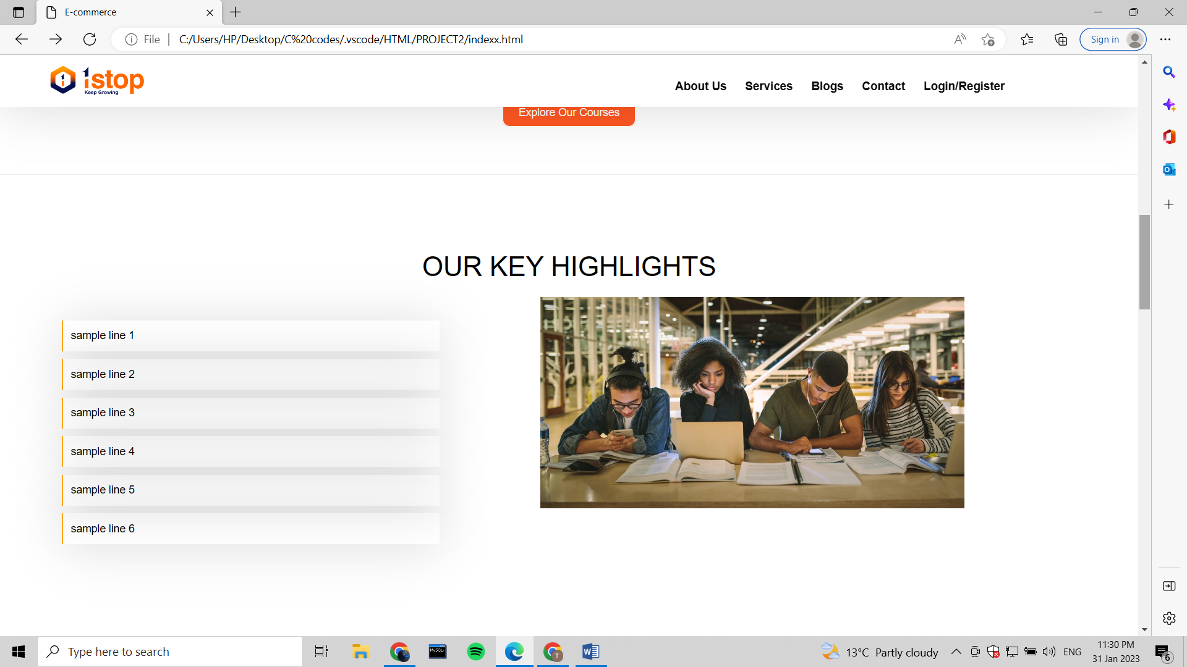

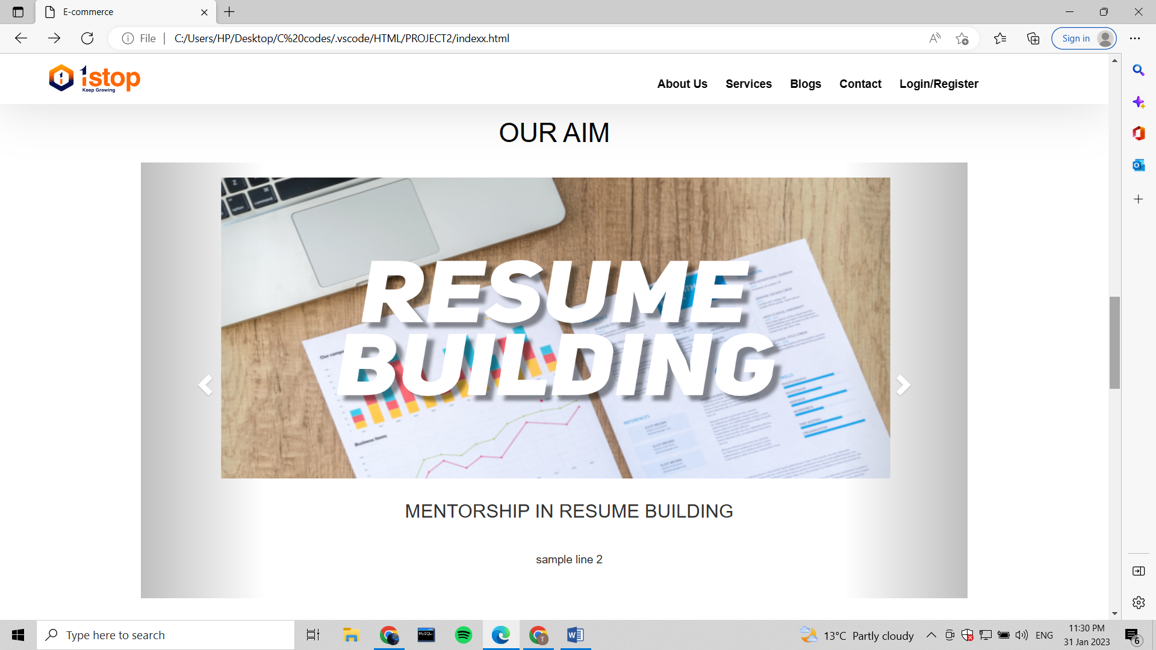

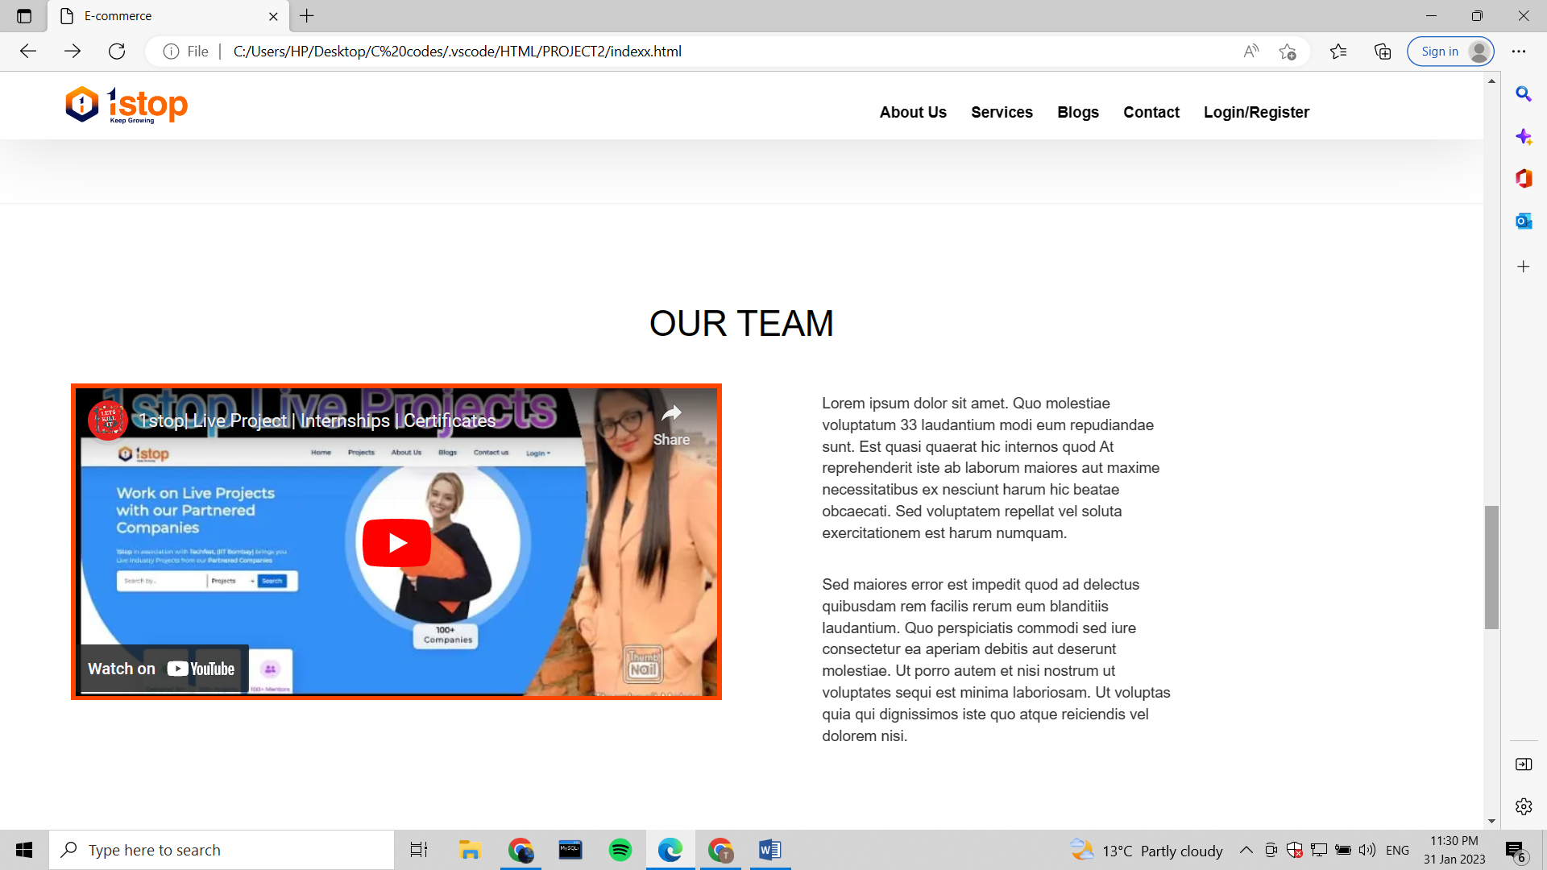

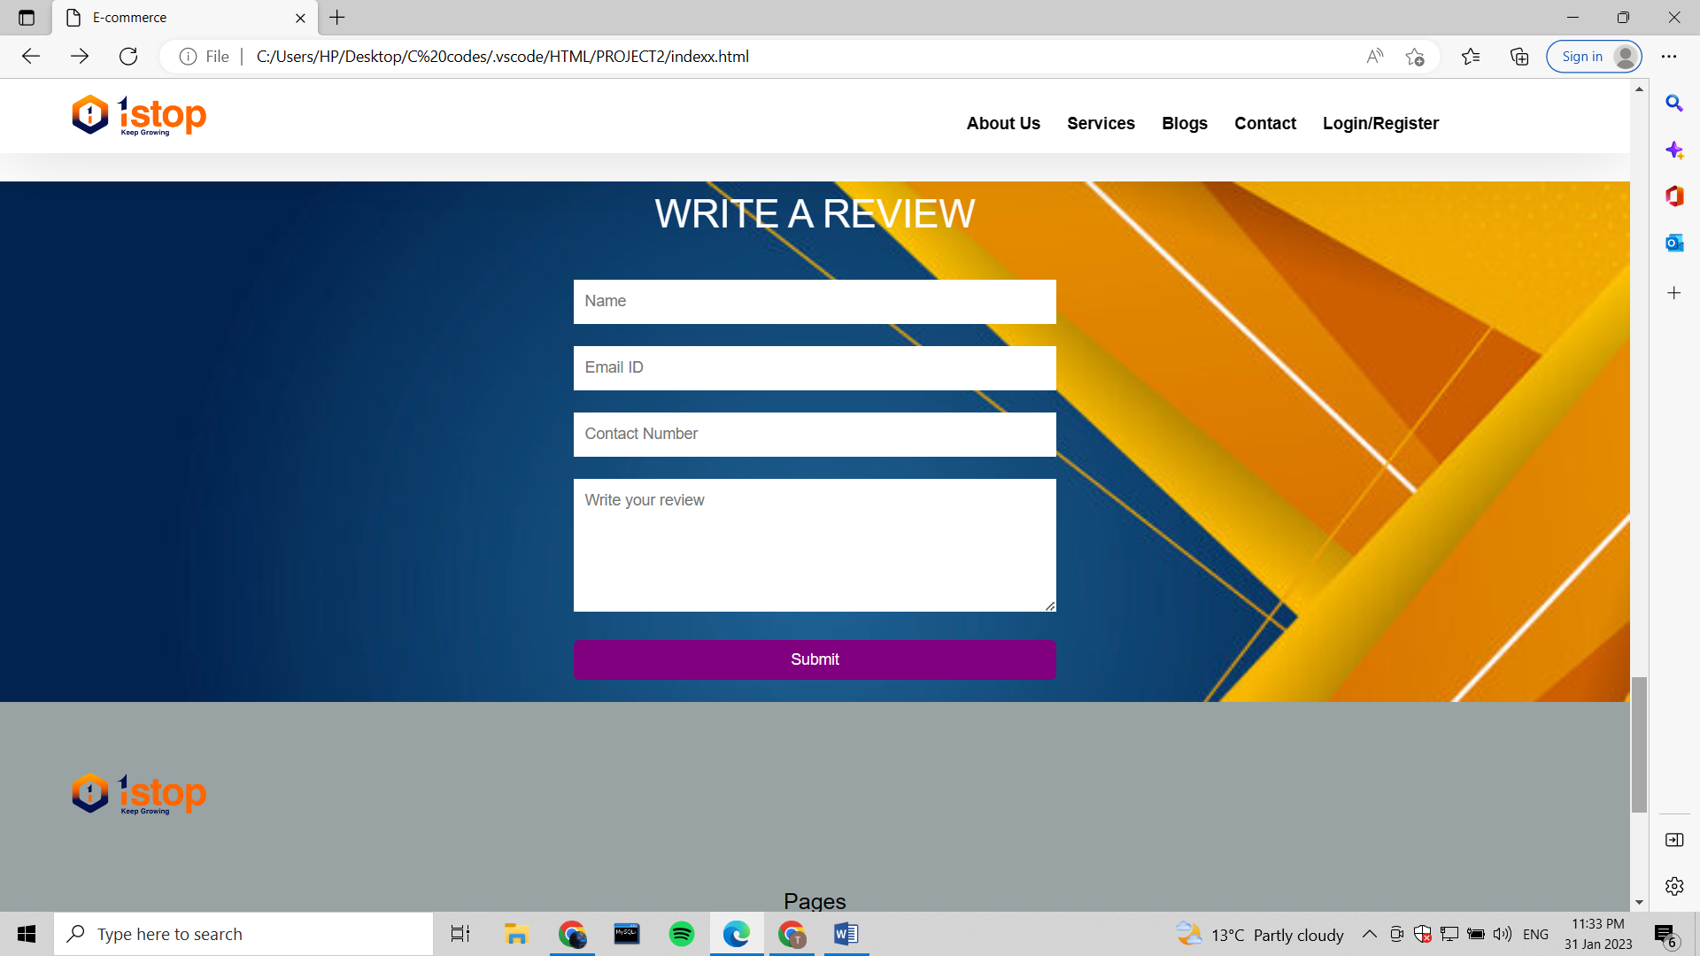

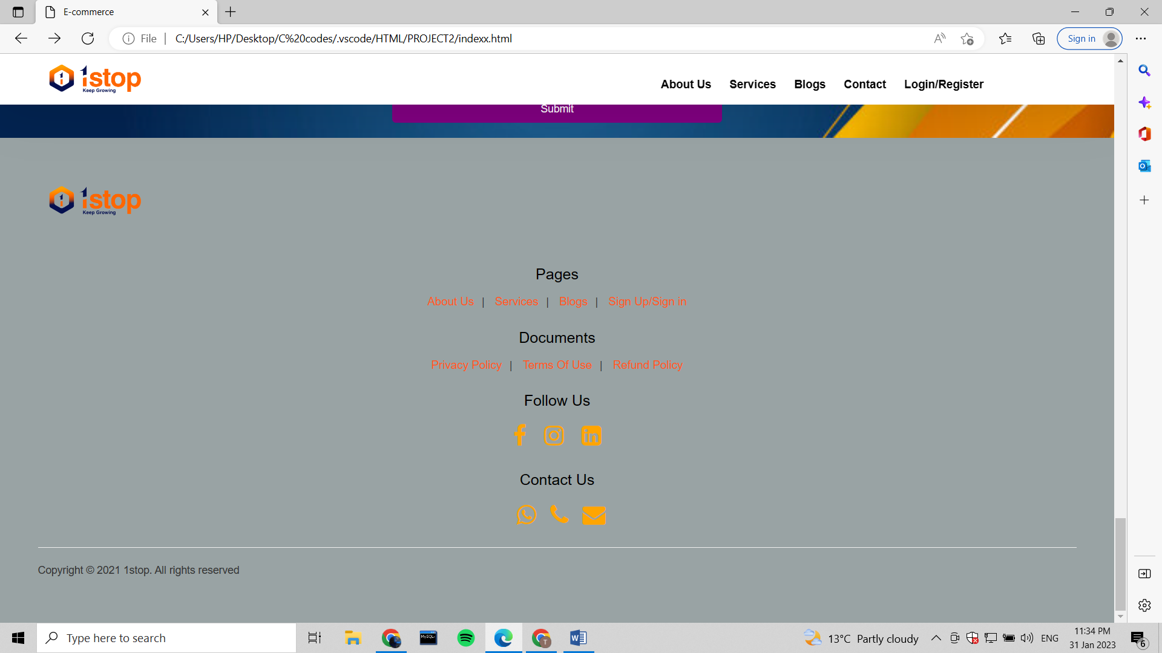



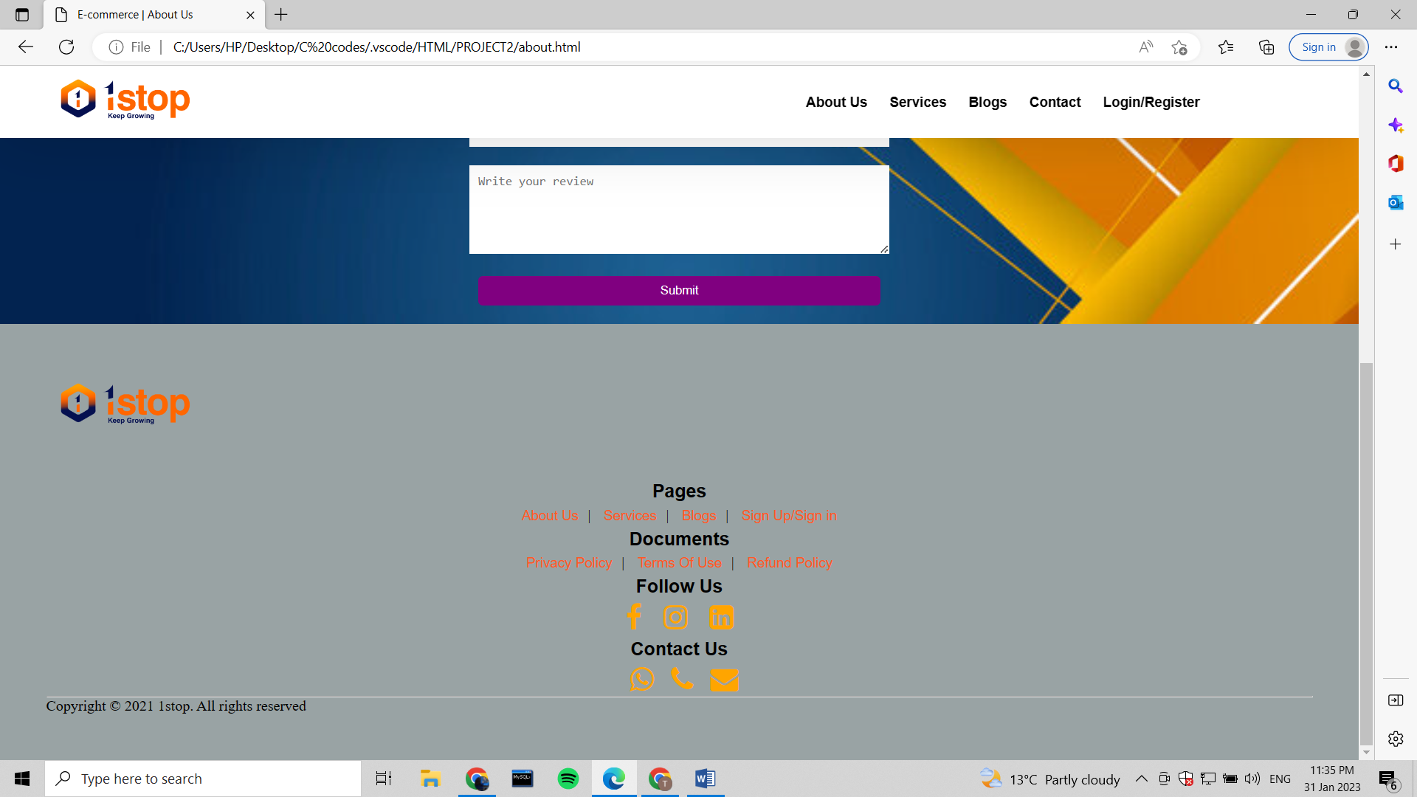



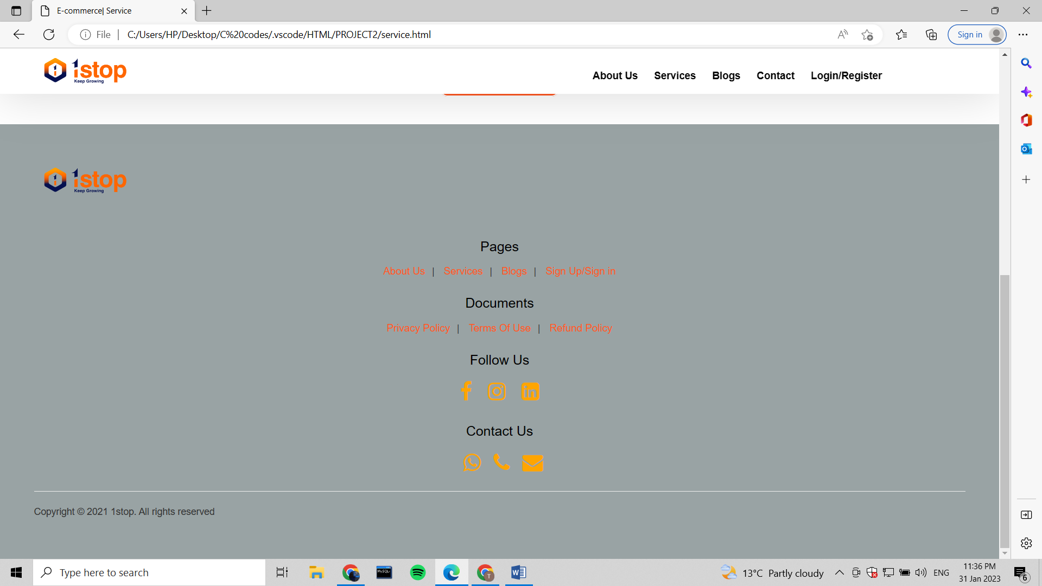

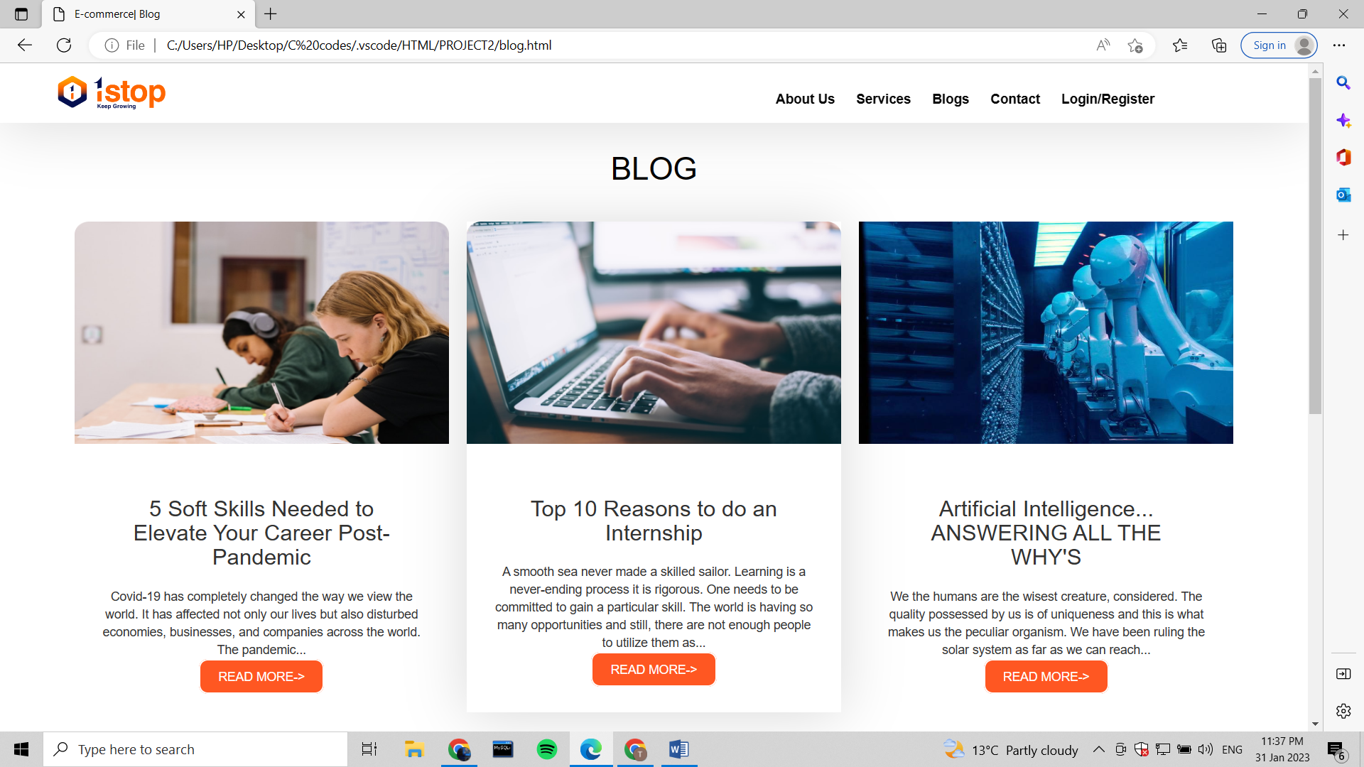

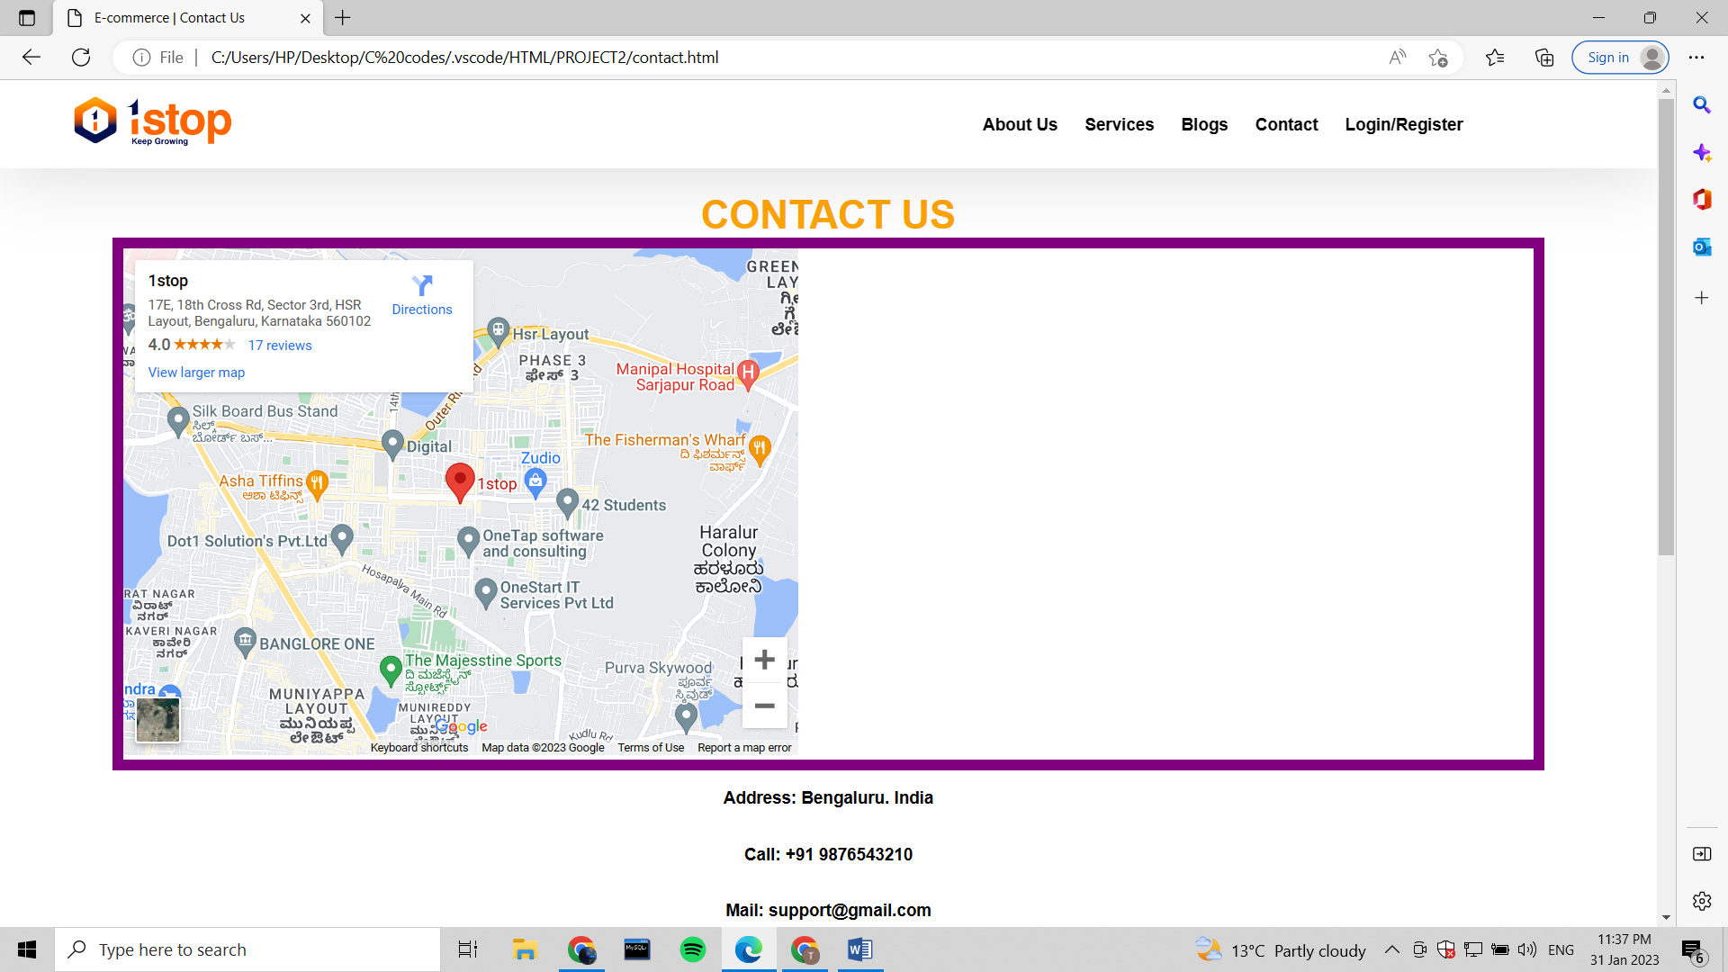

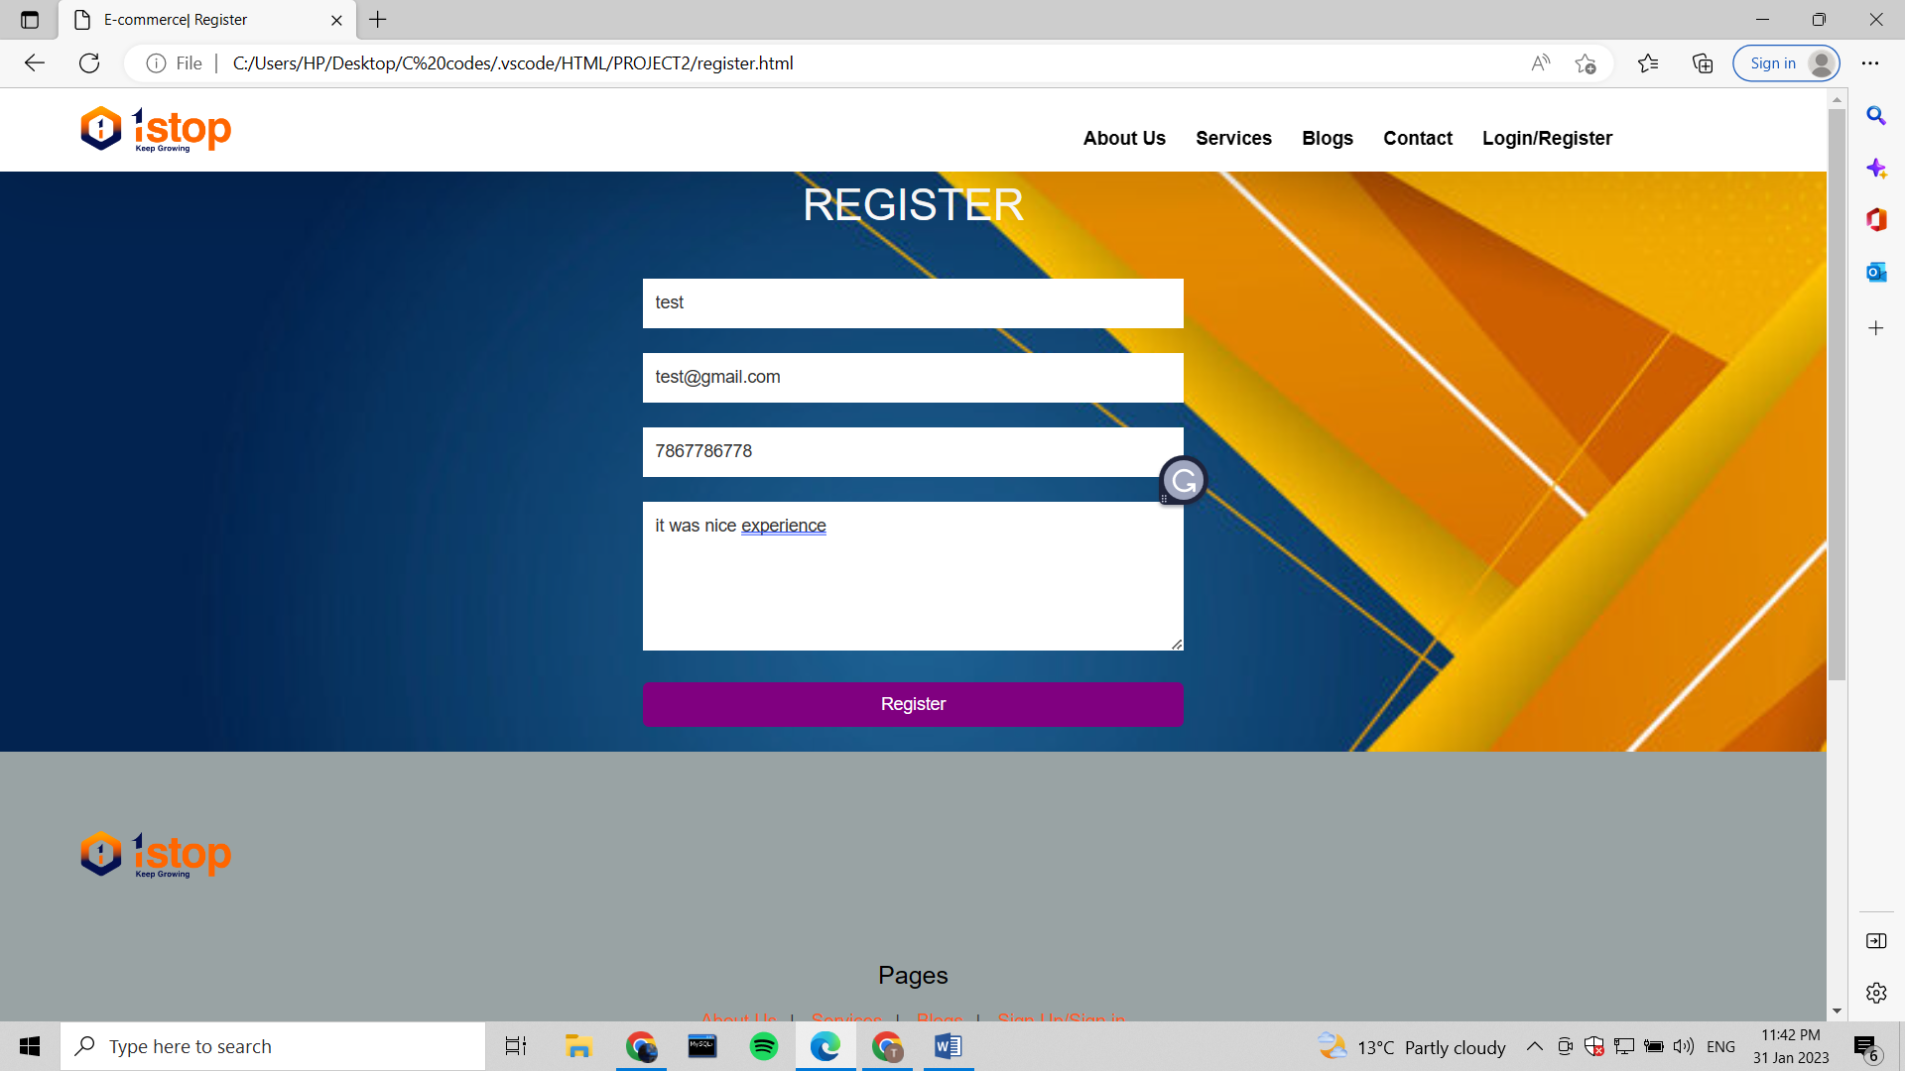

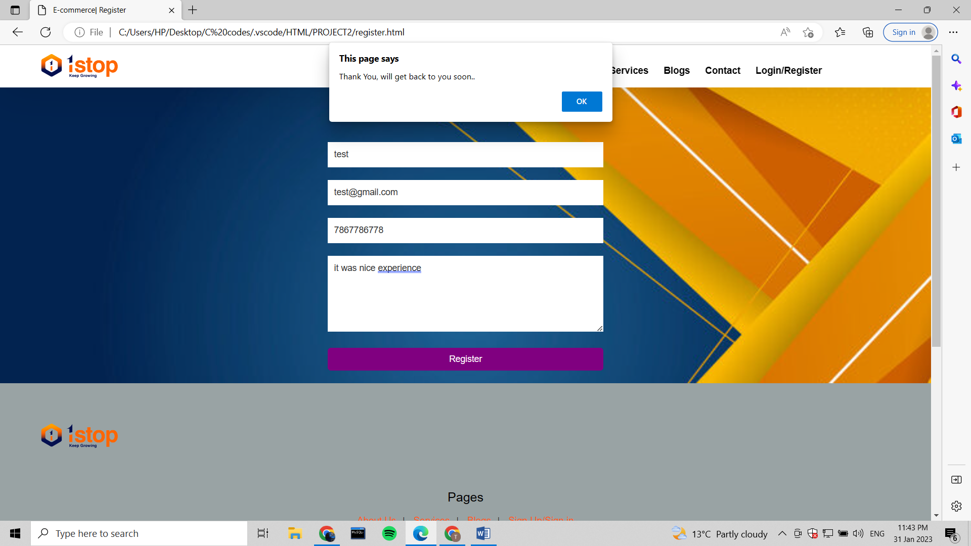

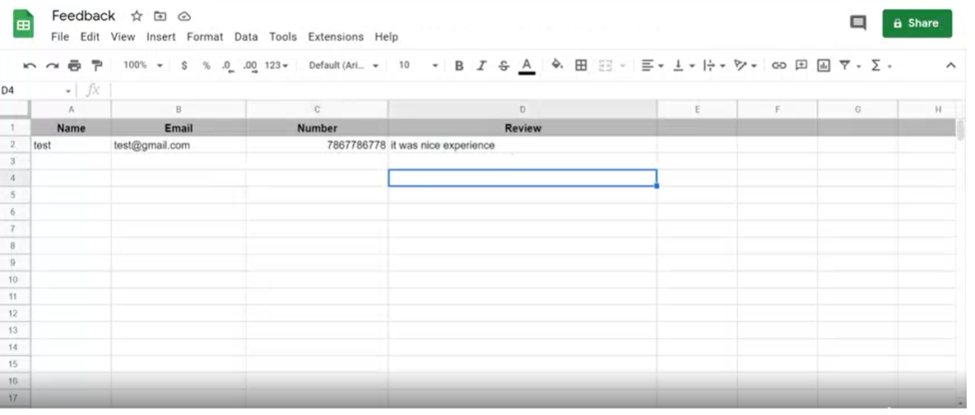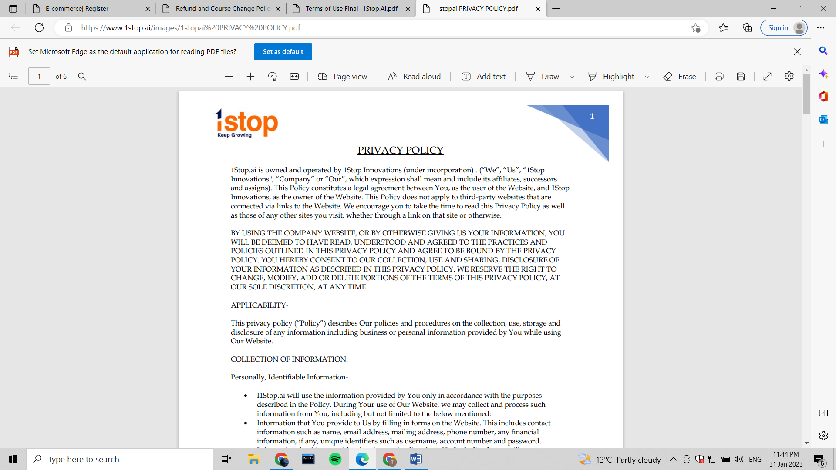

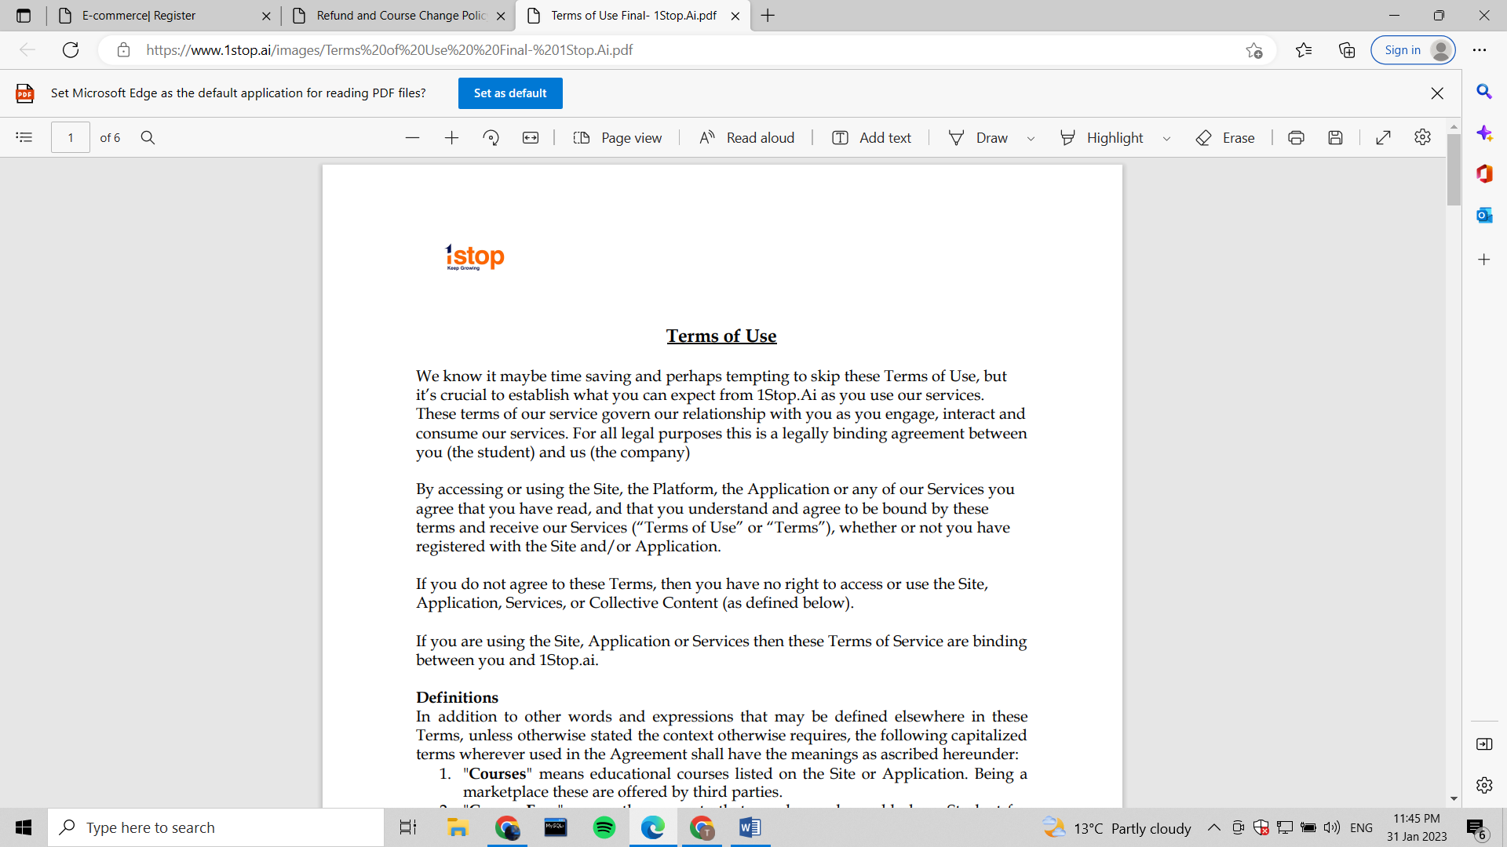

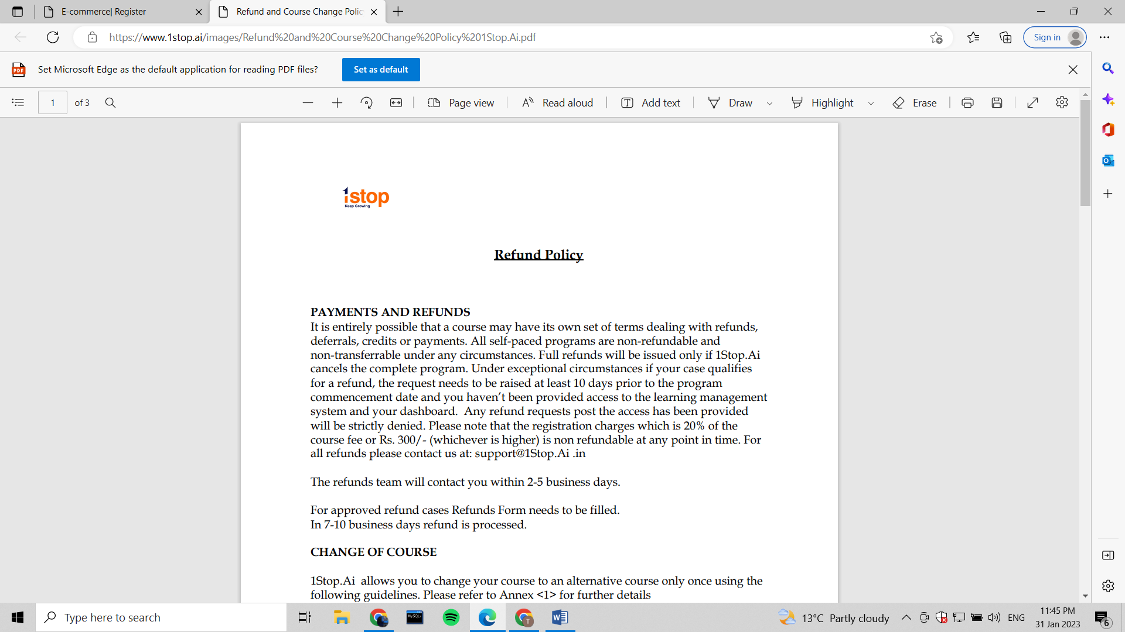

CONCLUSION:

Hyper Text Markup Language or HTML is a dominant programming language for web pages.  Through Web 2.0 tools it is becoming increasingly easier to design webpages, however knowing some HTML is still useful.  Many times, when working with blogs, Wilki’s, and even Facebook there is an HTML alternative where the user can modify the appearance of the task through HTML.

To design a successful website, one must first recognize what makes a website effective.  Then these skills can be applied to the technical development of learning to design a web page.